
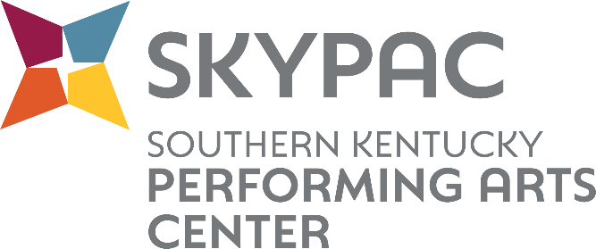

Contact: Makenzie Belcher| 270.904.5007| mbelcher@theskypac.com

Ramsey Theatre Company Announces Full Cast of
Steel Magnolias


BOWLING GREEN, KY – SKYPAC is thrilled to announce the full cast for Ramsey Theatre Company’s production of Steel Magnolias. This heartfelt comedy-drama explores the deep bonds of friendship, resilience, and love as these women navigate life’s joys and sorrows together.
“We are thrilled to bring this professional Ramsey Theatre Company production to SKYPAC! The show features a phenomenal cast, led by Film/TV and Broadway talent, bringing new life to this timeless classic,” said Diane DiCroce, Producing Artistic Director of Ramsey Theatre Company. “It’s a story of Southern Charm that tests the bonds of friendship.”
This small but mighty cast of eight brings star power, featuring talent from Film/TV and Broadway.
CAST LIST
M’Lynn Eatenton: Catherine Mary Stewart
Ouiser Boudreaux: Kirsti Carnahan*
Clairee Belcher, U/S Ouiser: Abby Apple Boes
Shelby Eatenton-Latcherie: McKenna Ogrodnik
Truvy Jones: Ashlee Quinn
Annelle Dupuy- Desoto: Abby Luckett
U/S Shelby, Annelle: Aubin Jefferson
U/S M’Lynn, Truvy, Clairee: Lacey Steele
*Appears through the courtesy of Actors’ Equity Association, the Union of Professional Actors and Stage Managers in the United States.

“I’m really stoked to get the opportunity to help share this funny, bittersweet play with SKYPAC audiences at their state-of-the-art theatre along with an immensely talented cast and creative team. This production is one more reason for me to be thankful this Thanksgiving,” said Tim Altmeyer, Broadway Veteran and Director of Steel Magnolias.
Rehearsals begin in January, leading up to two performances spanning across Saturday, February 21, and Sunday, February 22, at the Southern Kentucky Performing Arts Center (SKYPAC). “We are also looking forward to taking this show on the road (a Ramsey Theatre Company first) to the RiverPark Center in Owensboro on February 28th,” said Diane DiCroce Producing Artistic Director of Ramsey Theatre Company.
Tickets are on sale now and available at www.theskypac.com, by phone at (270) 904-1880, or in person at 601 College Street, Bowling Green, KY.
SKYPAC’s 2025–2026 Broadway Series is sponsored by Greenwood Ford Lincoln.
Steel Magnolias is sponsored by Service One Credit Union and co-sponsored by Med Center Health.

ABOUT RAMSEY THEATRE COMPANY
The Ramsey Theatre Company was formed through a generous gift from Robert P. Ramsey to produce professional-level musical theatre for the BRADD region. The Rita and Jim Scott Concert Hall at SKYPAC serves as its primary home. Auditions are held Nationally through online submissions and in-person auditions in New York City. Auditions for locally and regionally based actors are held in-person at the SKYPAC. Orchestra Kentucky provides live accompaniment in the Robin and David Ciochetty orchestra pit.

ABOUT SKYPAC
The Southern Kentucky Performing Arts Center (SKYPAC) is a premier arts and entertainment venue located in downtown Bowling Green, KY. Home to Ramsey Theatre Company, Orchestra Kentucky, and BG OnStage, SKYPAC presents a diverse lineup of Broadway shows, concerts, educational programs, and original theatrical productions that enrich the cultural life of the region. For more information, visit www.theskypac.com.

CAST BIOGRAPHIES

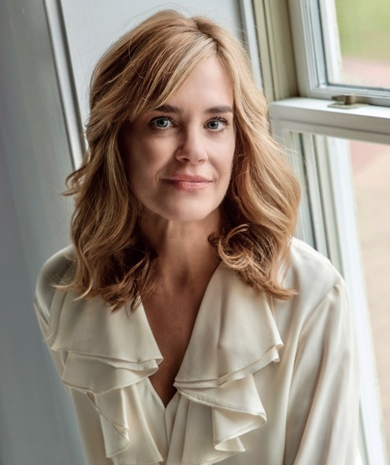
Catherine Mary Stewart (M’Lynn Eatenton) is a veteran of over 40 years as an actor. She began her performing career in Edmonton, Canada. After graduating from high school, Catherine enrolled in the highly regarded performing arts school, London Studio Centre, in London, England. During her tenure at the school, Catherine auditioned for the feature film, “The Apple”, and was cast in the lead female role of “Bibi”. The film was shot in Berlin, Germany for six weeks. After the release of “The Apple” debuting at the Montreal Film Festival, Stewart moved to Los Angeles, California. Catherine landed the role of “Kayla Brady” on “Days of Our Lives”. Kayla remains one of the most popular characters on “Days of Our Lives”. While still on the soap, Catherine was cast as the lead female character, “Maggie” in the feature film “The Last Starfighter”. This charming movie retains cult status to its many die-hard fans. Catherine was then cast as the lead, “Reggie” in another cult classic, “Night of the Comet”. Thom Eberhardt, the director and writer, and his creative genius made “Night of the Comet” one of the most unique and entertaining female driven movies of the 1980s. “Mischief”, a coming-of-age movie set in small-town Ohio in the 1950’s. Catherine played a single-minded, strong-willed teen, defying the cultural norm of the day and her conservative parents, to pursue true love. Catherine is well known for her role as “Gwen” in the hilarious comedy, “Weekend at Bernie’s is constantly referenced in politics, in TV, etc. Catherine has enjoyed an incredibly diverse career in movies portraying a wide range of characters from girl next door to an Uzi slinging apocalypse survivor, a rock and roll singer and musician in “Scenes from the Goldmine”, to a gun slinging, horseback riding, independent woman in the punk rock, western “Dudes”, with Jon Cryer, directed by Penelope Spheeris. Aaron Spelling, cast Catherine in the lavish mini-series, “Hollywood Wives”, based on the Jackie Collins epic novel about the dark inner workings of Hollywood. The illustrious cast included Anthony Hopkins, Candice Bergen, Rod Steiger and Angie Dickinson. “Sins” was another mini-series starring Joan Collins as Helene Junot. Catherine was cast as the young Helene, in WWII in Nazi occupied France. Again, Catherine was in the company of some of the greatest actors of our time such as Jean-Pierre Aumont, Lauren Hutton and Gene Kelly. “Passion and Paradise” reunites Catherine with Rod Steiger as the aristocratic father and daughter Nancy Oakes and Sir Harry Oakes. Set in the Bahamas in the era of World War II, this is a story full of deception and intrigue on an international scale with Armand Assante as her love. “The Sea Wolf” is based on the Jack London novel and set in the turn of the century. Charles Bronson as a brutal sea captain takes aboard aristocrat Christopher Reeve and a thief, Catherine that were stranded on the high seas. Along with Hallmark and Lifetime movies most recently she has appeared on popular series including “New Amsterdam”, “Limitless”, “White Collar”, and “Law and Order”. Catherine continues to work in front of the camera, but also writes, produces and directs.

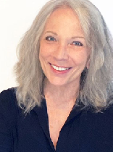
Kirsti Carnahan* (Ouiser) is delighted to make her Ramsey Theatre Company debut at SKYPAC, having played Ouiser Boudreaux at Music Theatre of Connecticut in 2019. Kirsti created the role of Marta in the Tony-Award nominated Kiss of the Spider Woman, playing in Toronto, London, and on Broadway with the legendary Chita Rivera and later with Vanessa Williams. She can be heard on both the London original cast recording and the Grammy-nominated Broadway recording. Other Broadway credits include the Alan Menken & Tim Rice pop oratorio King David (original cast recording), Baby (original cast recording), and the 1984 revival of The Three Musketeers. On National Tour she has performed Fantine in Les Miserables, Grizabella in Cats, and Grace Farrell in Annie. This past season, Kirsti received a CT Critic Circle Award nomination for her performance as Martha Watson in White Christmas at Music Theatre of CT. Other favorite roles: Daisy Werthan in Driving Miss Daisy, Rose in Gypsy, Dolly Levi in Hello, Dolly!, Vera Charles in Mame, Mrs. Lovett in Sweeney Todd (NH Professional Theatre Award, Best Actress in a Musical), Sister Aloysius in Doubt, Madame Arcati in Blithe Spirit, Fanny in Painting Churches, Olivia in Twelfth Night, Tracy Lord in The Philadelphia Story, Eva Peron in Evita, and Virginia in The Golden Age with Anne Pitoniak, among many others. (*Appears through the courtesy of Actors’ Equity Association, the Union of Professional Actors and Stage Managers in the United States.)

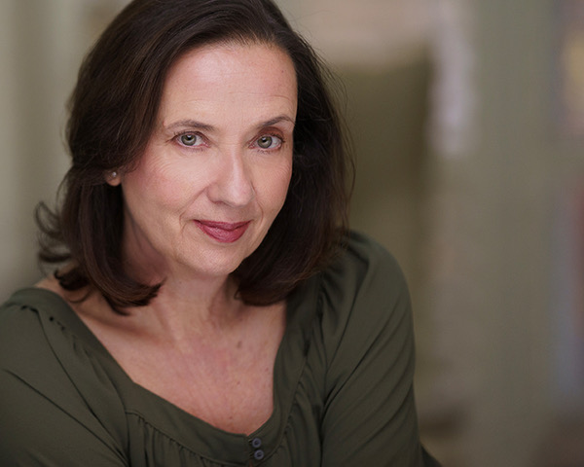
Abby Apple Boes (Clairee Belcher) Abby is excited to make her debut at The Ramsey Theater Company. Abby grew up in Phoenix, AZ, and has lived in Los Angeles, Las Vegas, and New York City. She currently resides in Denver, CO where she has lived since 1999. Recent productions include; Ouiser in Steel Magnolias at The Candlelight Dinner Theatre, Peg in A Jukebox for the Algonquin, Jeannie in The Great American Trailer Park Musical, Charlotte in Moon Over Buffalo, and Mae Brussell in Queen of Conspiracy (Miners Alley Performing Arts Center), Mama Murphy in Bright Star, Frieda/Betty in Sunday In The Park With George (Arvada Center); Rosemary in Tenderly: The Rosemary Clooney Musical, Polly in Other Desert Cities (Cherry Creek Theatre), Barbara Fordham in August: Osage County (Abster Productions/Dairy Center). Abby was also a featured singer in the Las Vegas extravaganza Jubilee at Bally’s Hotel and Casino and spent several years as featured singer for Cunard and Norwegian Cruise Lines. Abby would like to thank everyone at the Ramsey Theater Company for including me in this wonderful production. I hope you all enjoy your time in Chinquapin Parish!

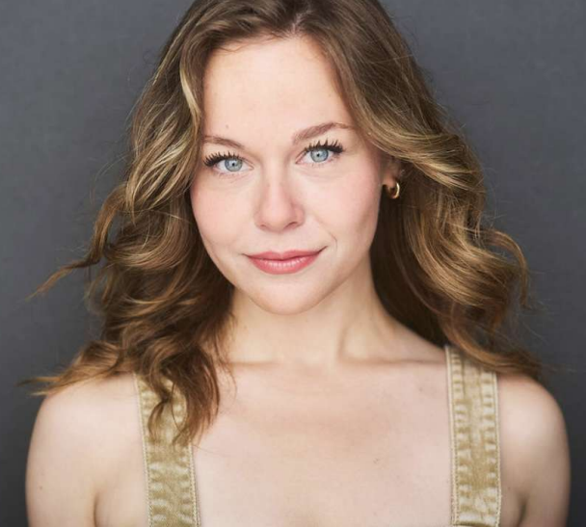

McKenna Ogrodnik (Shelby Eatenton-Latcherie) has credits from That Parenting Musical (Off-Broadway), Hunterdon Hills Playhouse, she’s a OG/current member of NYC division of The Satin Dollz @satindollz CCU alum - Chants Up! And she is Incredibly thankful to be here with Ramsey Theatre Company.


Ashlee Wilson Quinn (Truvy) is thrilled to be a member of the Ramsey Theatre Company. Her previous roles with the company include Miss Lynch in Grease, Aunt Em in The Wizard of Oz, and most recently in the world-premiere of The Best Gift: A Christmas Carol Musical as Mrs. Fezziwig. When not on stage, you will find Ashlee with WNKY News 40, where she wakes up with South Central Kentucky every weekday morning as the anchor for News 40 Sunrise and News 40 @ 9. She has performed locally with BG OnStage, Fountain Square Players, the Public Theatre of Kentucky, and with a favorite local band, Bueler’s Day Off.

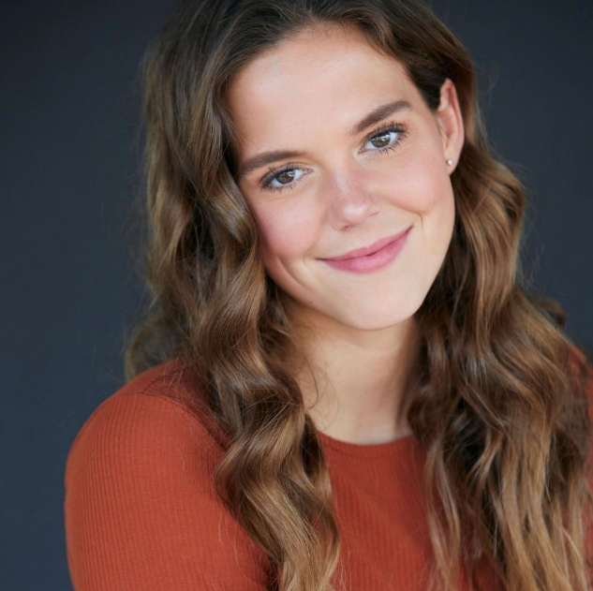
Abby Luckett (Annelle Dupuy-Desoto) is delighted to be a part of her second Ramsey Theatre production! With roles ranging from “Little Red” in Belmont University’s “Into the Woods,” to being cast in the original musical “His Story,” directed by two- time Tony nominee Jeff Calhoun, Abby is thrilled to be stepping on the stage again. Abby is most known for her social media presence as 1/2 of the internet couple “Abby and Ryan” and host of “That’s Life Podcast.” When Abby isn’t acting or filming, she spends her time running marathons… for fun. Abby would like to thank her family, friends, husband, Ramsey creative team, and God for supporting her through this journey.


Aubin Jefferson (U/S Shelby, Annelle) is thrilled to be back for her second show with Ramsey Theatre Company! Her recent credits include The Wizard of Oz (Ensemble), Little Women (Jo March), You're A Good Man, Charlie Brown (Lucy), and Snow White (Evil Queen Galiena).

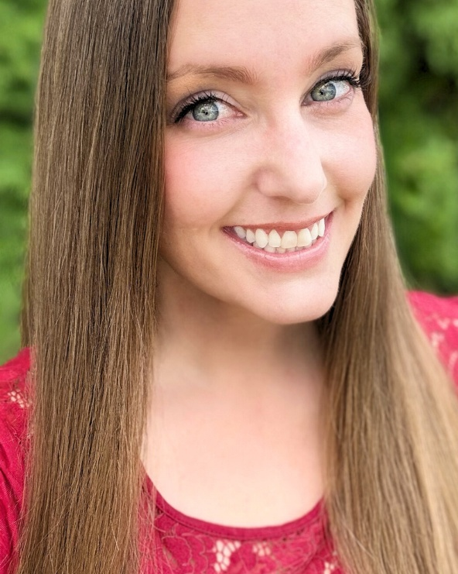
Lacey Steele (U/S M’Lynn, Truvy, Clairee) Lacey Steele grew up just down the road in Franklin, Ky. She holds a degree in Broadcast Journalism from WKU and formerly anchored the news at WBKO. After several years living out-of-state, her love for Kentucky drew her back home. She is now the Multi-Media Manager at Snodgrass Veterinary Medical Center in Bowling Green. Lacey has more than 30 years of dance experience, enjoys singing and has performed with several local bands, and has a deep love for the theatre. In recent years, she has portrayed the roles of Cha Cha in Grease with Ramsey Theatre Company, as well as Mrs. Phelps in Matilda, Ellen in Oklahoma, and Princess Lotta Kargo in Murder in the Magnolias, all performed through the Franklin-Simpson Community Arts Council.

