

CONTACT: Makenzie Belcher (270) 904-5000 ext. 5007 mbelcher@theSKYPAC.com

SKYPAC Announces 2026-2027 Orchestra Kentucky Season!


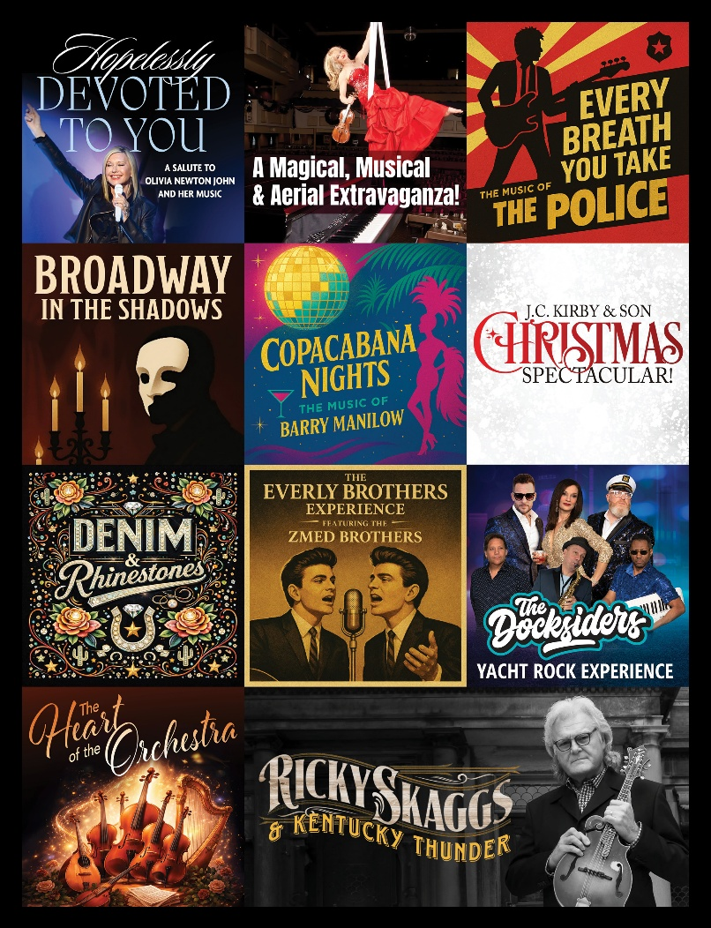

February 27, 2026
Bowling Green, KY —Today, SKYPAC announced details of Orchestra Kentucky’s 2026-2027 season, its 27th year. Highlights include a tribute to Olivia Newton-John, the high-flying artistry of Janice Martin in A Magical, Musical & Aerial Extravaganza, the iconic hits of The Police and a special show with bluegrass singer, Ricky Skaggs. The season also features Broadway’s dark side, the timeless music of Barry Manilow, the holiday favorite J.C. Kirby & Son Christmas Spectacular, plus classic country, Yacht Rock, and the sweeping beauty of Orchestra Kentucky’s strings. A lineup full of variety and nostalgia awaits.
There are three season ticket packages available-The Jim Johnson Nissan/ Hyundai Retro Series, The Graves Gilbert Clinic Variety Series and The Full Series Subscription. Details are available online at www.TheSKYPAC.com, and ticket packages may be purchased by calling (270) 904-1880 or in person at 601 College Street in downtown Bowling Green open 9 am to 5 pm weekdays.
The new season begins Saturday, July 18, 2026 with Hopelessly Devoted to You a salute to Olivia Newton John. We hope you will join us and get the new season started on a high note!
Orchestra Kentucky’s 2026-2027 Season
The Retro Series is sponsored by Jim & Darlene Johnson and Jim Johnson Nissan/Hyundai and The Variety Series is sponsored by Graves Gilbert Clinic.

- Hopelessly Devoted to You- A Salute to Olivia Newton John: Saturday, July 18, 2026
Co-sponsor: BGMU Fiber

- A Magical, Musical & Aerial Extravaganza- with Janice Martin: Saturday, August 22, 2026
Co-sponsor: Bell, Orr, Ayers & Moore, P.S.C

- Every Breath You Take– Music of The Police: Saturday, September 12, 2026

- Broadway In The Shadows– Saturday, October, 17, 2026
Concert Sponsor: Pinnacle Financial Partners; Co-sponsor: Amy & David Chandler

- Copacabana Nights: The Music of Barry Manilow– Saturday, November 7, 2026
Co-sponsor: Newton Financial Group

- J.C. Kirby & Son Christmas Spectacular – Saturday, December 12, 2026
Title Sponsor: J.C. Kirby & Son Funeral Chapels & Crematory; Co-sponsor: Houchens Industries, The Glenview Trust Company, and Joe & Sharon Davis
- Denim & Rhinestones: The Rewinders– Saturday, February 13, 2027
Co-Sponsor: Debra L. Broz Attorneys at Law, PLC

- The Everly Brothers Experience Featuring the Zmed Brothers – Saturday, March 13, 2027
Concert Sponsor: Franklin Bank & Trust

- The Docksiders- Yacht Rock Experience- Saturday, April 24, 2027

- The Heart of the Orchestra: From Four Seasons to Forever Classics- Saturday, May 15, 2027
Co-sponsor: Drs. Sharon Mutter & Hank Wohltjen

*SPECIAL: Ricky Skaggs with Orchestra Kentucky Saturday, October 24, 2026
(Included with your full series subscription)

ABOUT ORCHESTRA KENTUCKY
Founded in 2000 by Music Director Jeffrey Reed and a dedicated group of community leaders, Orchestra Kentucky began with a simple vision: to bring professional orchestral music to Bowling Green and the Commonwealth. What started with no funding and a single concert attended by 150 patrons has grown into a thriving regional orchestra serving audiences across Kentucky and beyond.
Known for its creative, audience-focused programming, Orchestra Kentucky blends beloved classical masterworks with popular favorites, rock collaborations, show tunes, and innovative themed performances. The orchestra’s popular symphonic rock series featuring The Rewinders has expanded its reach across multiple states, while annual traditions and diverse programming continue to attract new generations of concertgoers.
A cornerstone of its mission, “Change lives…one note at a time,” Orchestra Kentucky is deeply committed to education and community engagement through youth orchestras, string instruction programs, school-day performances, and pre-concert educational talks. Now performing as part of SKYPAC, the orchestra continues to grow its artistic impact, serving thousands each season through inspiring performances and meaningful outreach.

ABOUT SKYPAC
The Southern Kentucky Performing Arts Center (SKYPAC) is a premier arts and entertainment venue located in downtown Bowling Green, KY. Home to Ramsey Theatre Company, Orchestra Kentucky, and BG OnStage, SKYPAC presents a diverse lineup of Broadway shows, concerts, educational programs, and original theatrical productions that enrich the cultural life of the region. For more information, visit www.TheSKYPAC.com.

