

SKYPAC Launches 2026 Public Art Invitational in Partnership with the City of Bowling Green and Warren County
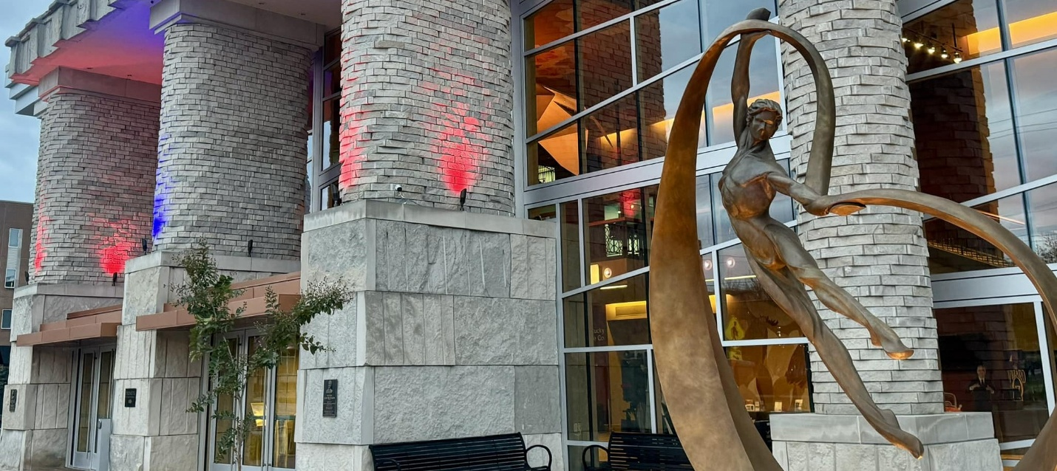
FOR IMMEDIATE RELEASE- February 27, 2026
Bowling Green, KY — The Southern Kentucky Performing Arts Center (SKYPAC), in partnership with the City of Bowling Green and Warren County, is proud to announce the launch of the 2026 SKYPAC Public Art Invitational, a juried outdoor sculpture exhibition that will bring new public art installations to prominent locations throughout the community.
The exhibition call will open February 27, 2026, and remain open through April 30, 2026. Artists residing in Kentucky and across the United States are invited to submit proposals for new sculptures for sale or to lend existing sculptures for a one-year outdoor exhibition.
Selected artworks will be installed on City of Bowling Green and Warren County–owned properties, including Circus Square Park, the Chamber Walk, Capitol Alley, and various recreational parks, serving as visible landmarks that contribute to the cultural and aesthetic vibrancy of the region.
“Public art has a way of turning everyday spaces into places people remember,” said Jessica Snodgrass, Marketing & Sales Director at SKYPAC. “We’re excited to bring meaningful sculpture into the heart of Bowling Green, work that sparks curiosity, starts conversations, and reflects the creativity that already lives here.”
Approximately 15–20 sculptures will be selected by a Public Art Selection Committee composed of professional and academic advisors with expertise in art, design, and public space planning. Each selected work will be installed on a granite base in high-visibility pedestrian areas throughout Bowling Green.
The exhibition aims to:
· Strengthen Bowling Green’s cultural identity
· Support Kentucky-based artists
· Activate public spaces through visual art
· Contribute to ongoing revitalization efforts in the city and county
Artists must be 18 years of age or older. Sculptures must be suitable for outdoor installation and constructed of durable materials capable of withstanding seasonal weather conditions.
Selected artists will receive a stipend to assist with transportation and installation costs. Applications and full guidelines will be available at TheSKYPAC.com/public-art February 27, 2026.
For questions regarding the Public Art Invitational, contact:
Jessica Snodgrass Marketing & Sales Director Southern Kentucky Performing Arts Center 270-904-5000 ext. 7005 jsnodgrass@TheSKYPAC.com
ABOUT SKYPAC
The Southern Kentucky Performing Arts Center (SKYPAC) is a premier arts and entertainment venue located in downtown Bowling Green, KY. Home to Ramsey Theatre Company, Orchestra Kentucky, and BG OnStage, SKYPAC presents a diverse lineup of Broadway shows, concerts, educational programs, and original theatrical productions that enrich the cultural life of the region. For more information, visit www.TheSKYPAC.com.

