

CONTACT: Jessica Snodgrass (270) 904-5000 ext. 7005, jsnodgrass@theskypac.com

Southern Kentucky Performing Arts Center Announces the Summer Lineup for 2026 “Concerts in the Park” At Circus Square

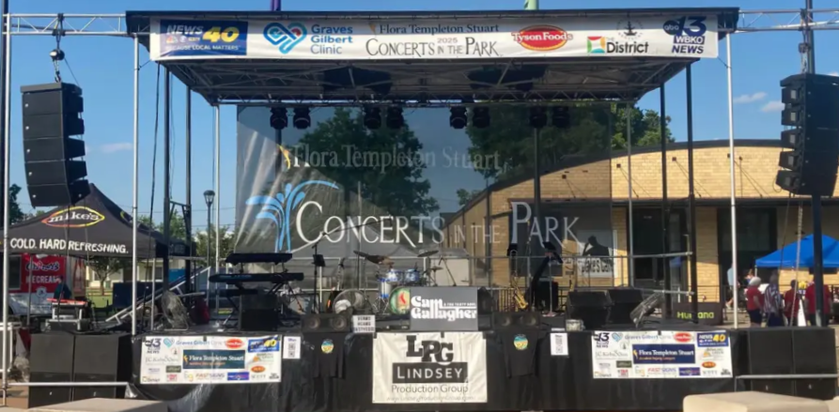

BOWLING GREEN, KY — The Southern Kentucky Performing Arts Center (SKYPAC) has announced the 2026 lineup for Concerts in the Park, Bowling Green’s beloved free summer music series. Thank You to our Title Sponsor, Flora Templeton Stuart and Headliner Sponsor, Graves Gilbert Clinic- we appreciate your continued support!

The lineup is as follows:

June 12- C Dock Boys
Sponsor: Hospice of Southern Kentucky

June 19- Men of A Certain Age
Sponsor: Merrill Lynch

June 26 – No Deposit Band

July 10-Tailgate

July 17-FreQuency

July 24-Six Gun Five

July 31- Van Winkle & The Spirits

August 7- Bad Navigator

August 14- Peter The Freshman

August 21- Andy & The Rockers

August 28- Tyrone Dunn & Kin-Foke

Each of these dates falls on a Friday night with a start time of 7 PM. In the event a concert is cancelled due to weather, SKYPAC has secured September 4 and September 11 as designated make-up dates at Circus Square Park. SOKY Marketplace is no longer designated as a rain date location.

Since its inception, the series has been made possible through the generous support of local sponsors and community partners. We would like to send a special thank you to the City of Bowling Green, Bowling Green Parks & Recreation, presenting sponsor Flora Templeton Stuart Accident Injury Lawyers, Graves Gilbert Clinic, Lindsey Production Group, Franklin Bank & Trust, J.C. Kirby & Son Funeral Chapels and Crematory, The Mint Gaming Hall, RASK (Realtor Association of Southern Kentucky), Houchens Industries, Liberty Federal Credit Union, WBKO and WNKY, and countless local businesses and volunteers. For more info, visit www.TheSKYPAC.com. We hope to see you Friday nights all summer long!

ABOUT SKYPAC
The Southern Kentucky Performing Arts Center (SKYPAC) is a premier arts and entertainment venue located in downtown Bowling Green, KY. Home to Ramsey Theatre Company, Orchestra Kentucky, and BG OnStage, SKYPAC presents a diverse lineup of Broadway shows, concerts, educational programs, and original theatrical productions that enrich the cultural life of the region. For more information, visit www.theskypac.com.

