

Contact: Makenzie Belcher| 270.904.5007| mbelcher@theskypac.com

Ramsey Theatre Company and Orchestra Kentucky to Team Up for Rodgers & Hammerstein’s Carousel, A Concert on April 25
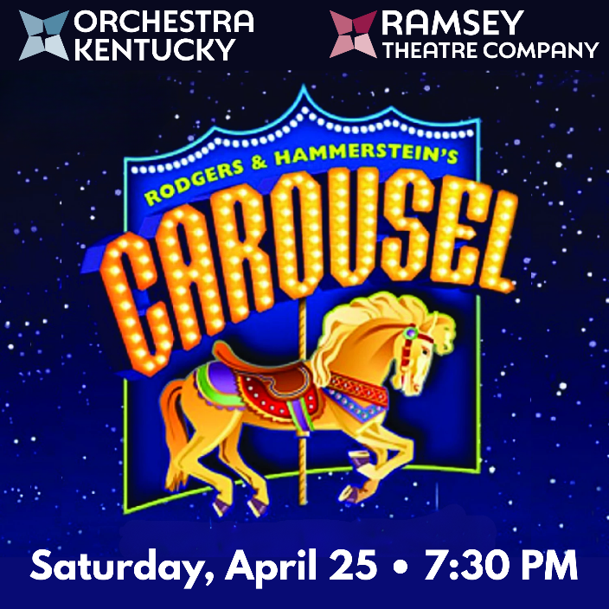

BOWLING GREEN, KY – Orchestra Kentucky and Ramsey Theatre Company unite for Carousel, A Concert, celebrating Rodgers & Hammerstein’s beloved score featuring unforgettable songs like If I Loved You, June Is Bustin’ Out All Over, and You’ll Never Walk Alone. This special evening highlights two of SKYPAC’s resident companies- Ramsey Theatre Company and Orchestra Kentucky, bringing together world-class, national, and local talent to tell powerful stories through music and song.
The performance will feature guest conductor Joseph Trafton, a Bowling Green native who has spent the past 20 years conducting in Germany. He returns home for this special night of music. Learn more at josephtrafton.com.
Starring in the concert are acclaimed Broadway performers Jeremy Stolle and Elizabeth Welch, portraying Billy Bigelow and Julie Jordan. Both bring extensive Broadway and concert experience, including appearances in The Phantom of the Opera. Jeremy is also the founder of his own production company and currently appears on Broadway in Masquerade by Andrew Lloyd Webber.
Bowling Green native Andy Stahl will perform the role of the Starkeeper. Andy has built a substantial career in film and television and has recently returned to Bowling Green, where he now resides full-time. He is also an alumnus of Western Kentucky University. Learn more at: https://en.wikipedia.org/wiki/Andrew_Stahl.
Additional cast members include Grace Trenouth as Carrie Pipperidge, an RTC intern and recent Orchestra Kentucky Bowling Green soloist currently attending Bard Conservatory, and Elijah Milburn as Enoch Snow, an RTC performer and recent graduate of Western Kentucky University. The role of Nettie will be performed by Dr. Tiffany Bostic Brown, head of Musical Theatre and Voice at WKU.
Ron Trenouth joins the cast as Dr. Seldon, bringing his experience as a Broadway alum. Also featured are Jesse McFarland, a National Tour and Ramsey Theatre Company alum, as Jigger Craigin, and Jonathan and Hannah Vanderpool, who have performed with both Orchestra Kentucky and Ramsey Theatre Company.
Kasey Taylor, Xavier Gravil, and Amberlin Burgett round out the Youth Ensemble, bringing experience from both BG OnStage and Ramsey Theatre Company. The Orchestra Kentucky Chorale will also play a key role in this concert. With so much talent coming together, this is a night you won’t want to miss.
This special performance is one night only—Saturday, April 25 at 7:30 PM at the Southern Kentucky Performing Arts Center (SKYPAC).
Tickets are on sale now and available at www.theskypac.com, by phone at (270) 904-1880, or in person at 601 College Street in Bowling Green.

CAROUSEL, A CONCERT is presented by arrangement with Concord Theatricals on behalf of The Rodgers & Hammerstein Organization. www.concordtheatricals.com
Thank you to our Variety Series Sponsor: Graves Gilbert Clinic

ABOUT RAMSEY THEATRE COMPANY
The Ramsey Theatre Company was formed through a generous gift from Robert P. Ramsey to produce professional-level musical theatre for the BRADD region. The Rita and Jim Scott Concert Hall at SKYPAC serves as its primary home. Auditions are held Nationally through online submissions and in-person auditions in New York City. Auditions for locally and regionally based actors are held in-person at the SKYPAC. Orchestra Kentucky provides live accompaniment in the Robin and David Ciochetty orchestra pit.

ABOUT ORCHESTRA KENTUCKY
Orchestra Kentucky was founded in the summer of 2000 by Jeff Reed and Mike Thurman, who saw a need for a professional orchestra in Bowling Green. With no funding and just a shared vision, they gathered a group of friends including Duncan McKenzie, Evan Walters, Chuck and Janet Smith, and Greg and Helen Motter to bring the idea to life. Jeff Reed was named music director.

ABOUT SKYPAC
The Southern Kentucky Performing Arts Center (SKYPAC) is a premier arts and entertainment venue located in downtown Bowling Green, KY. Home to Ramsey Theatre Company, Orchestra Kentucky, and BG OnStage, SKYPAC presents a diverse lineup of Broadway shows, concerts, educational programs, and original theatrical productions that enrich the cultural life of the region. For more information, visit www.theskypac.com.

