

Contact: Makenzie Belcher| 270.904.5000 ext. 5007| mbelcher@theskypac.com

Ramsey Theatre Company Announces Full Cast of
Disney’s The Hunchback of Notre Dame
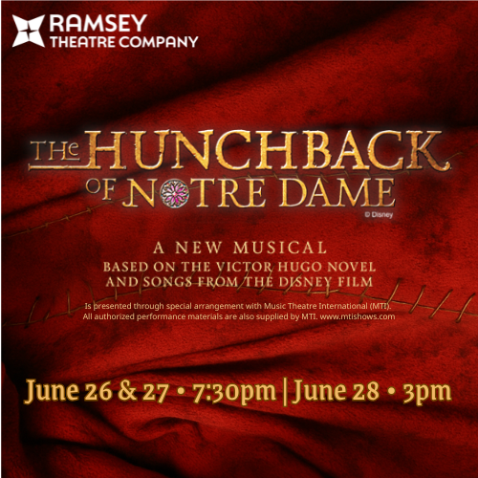

BOWLING GREEN, KY – SKYPAC is thrilled to announce the full cast for Ramsey Theatre Company’s production of Disney’s The Hunchback of Notre Dame, happening June 26, 27, and 28. This timeless tale, based on Victor Hugo’s epic novel and the beloved Disney animated feature, is a sweeping musical journey you won’t want to miss experiencing in person.
This impressive cast of thirty-four, plus a choir of twenty, features performers with experience in New York City, on Broadway National Tours, and on stages across the country and region. The production also highlights familiar faces from Ramsey Theatre Company productions, while Orchestra Kentucky takes its place of honor in the Robin and David Ciochetty Orchestra Pit.
“I am so excited to work with this amazing cast that brings together the very best of our regional talent as well as out-of-town actors and artists to tell this classic story. Audiences will be able to hear the glorious score of this show as if they were in the Notre Dame Cathedral itself,” said Diane DiCroce, Producing Artistic Director of Ramsey Theatre Company.
This musical features music by Alan Menken (“Beauty and the Beast”, “Little Mermaid”, “Little Shop of Horrors”) and lyrics by Stephen Schwartz (“Wicked”, “Godspell”, “Pippin”) and is based on the 1996 animated Disney classic film.
Multi-Dove award and Grammy award winning songwriter Mr. Dick Tunney will be Music Directing and conducting Orchestra Kentucky. “I am honored to again be in the pit for a Ramsey Theatre Company production. The Hunchback of Notre Dame has been recognized as one of Alan Menken’s best scores ever. A spectacular story based on the Victor Hugo novel with tremendous music will bring a rich and colorful performance to SKYPAC’s patrons,” said Music Director Dick Tunney.
Choreography will be led by Jake Dukes, Ramsey Theatre Company veteran (“Cinderella”, “Grease”) and recent alumnus of Western Kentucky University’s Dance program. Jake was the Associate Choreographer for last year‘s blockbuster Ramsey Theatre Company production of the “Wizard of Oz”. “What I am looking forward to the most is getting to see my vision come to life and getting to fully experience the storytelling process as a choreographer,” said Choreographer Jake Dukes.
Cast members include Tucker Boyes (Frollo) and Max DeSantis (Clopin), both recently on the Broadway National Tour of “The Addams Family”. Astoncia Bhagat (Esmeralda) and Chris Monell (Phoebus) both previously onstage with Actors Theatre of Louisville and Christian Leigh (Quasimodo) Manhattanville University alum, currently based in New York City.

Check out the full cast below!
CAST LIST
Quasimodo- Christian Leigh
Frollo- Tucker Boyes
Esmeralda- Astoncia Bhagat
Phoebus- Chris Monell
Clopin- Max DeSantis

Frederic, U/S Phoebus- Matt Propst
Florika, U/S Esmeralda- Bailey Bryant
Father Dupain, U/S Frollo- Shawn Quinn
St Aphrodisius- Gage Carnes
Jehan- Nate Simpson
Madame- Emily Barr
U/S Quasimodo, U/S St. Aphorodisius- Joseph Hanrahan
U/S Clopin, U/S Frederic, U/S Jehan- Harrison Belcher
Storyteller, U/S Florika, Swing- Emma Puerta
U/S Madame- Brittany Gatlin-Lloyd

Storytellers:
Emily Barr, Keenan Beasley, Harrison Belcher, Bailey Bryant, Gage Carnes,
Wesley Christensen, Reili Farmer, Brittany Gatlin-Lloyd, McCaleb Hanks, Joseph Hanrahan, Cameron Hepp, Aubin Jefferson, Ella Jones, Sam Lemmon, Bern Miranda, Brinlee Price, Matt Propst, Emma Puerta, Nate Simpson, Brooke Vinson

Youth Ensemble:
Mikey Borton, Amberlin Burgett, Xavier Gravil, M Lemmon, Gavin Perry, Grace Prather, Kasey Taylor, Lainey Kate Tolbert

Rehearsals begin in May, leading up to three performances spanning across Friday, June 26, Saturday, June 27, (7:30 PM) and Sunday, June 28, (3:00 PM) at the Southern Kentucky Performing Arts Center (SKYPAC).
Tickets are on sale now and available at www.theskypac.com, by phone at (270) 904-1880, or in person at 601 College Street, Bowling Green, KY.
SKYPAC’s 2025–2026 Broadway Series is sponsored by Greenwood Ford Lincoln.
Disney’s The Hunchback of Notre Dame is sponsored by Med Center Health. Big thank you also to Music Director Sponsor, Flora Templeton Stuart Accident Injury Lawyers and Set Sponsor, Harlin Technical.

ABOUT RAMSEY THEATRE COMPANY
The Ramsey Theatre Company was formed through a generous gift from Robert P. Ramsey to produce professional-level musical theatre for the BRADD region. The Rita and Jim Scott Concert Hall at SKYPAC serves as its primary home. Auditions are held Nationally through online submissions and in-person auditions in New York City. Auditions for locally and regionally based actors are held in-person at the SKYPAC. Orchestra Kentucky provides live accompaniment in the Robin and David Ciochetty orchestra pit.

ABOUT ORCHESTRA KENTUCKY
Orchestra Kentucky was founded in the summer of 2000 by Jeff Reed and Mike Thurman, who saw a need for a professional orchestra in Bowling Green. With no funding and just a shared vision, they gathered a group of friends including Duncan McKenzie, Evan Walters, Chuck and Janet Smith, and Greg and Helen Motter to bring the idea to life. Jeff Reed was named music director.

ABOUT SKYPAC
The Southern Kentucky Performing Arts Center (SKYPAC) is a premier arts and entertainment venue located in downtown Bowling Green, KY. Home to Ramsey Theatre Company, Orchestra Kentucky, and BG OnStage, SKYPAC presents a diverse lineup of Broadway shows, concerts, educational programs, and original theatrical productions that enrich the cultural life of the region. For more information, visit www.theskypac.com.

