

Contact: Makenzie Belcher| 270.904.5000 ext. 5007 | mbelcher@theskypac.com

SKYPAC Ranked Among Pollstar’s Top-Grossing Theatres in the World, No. 1 in Kentucky
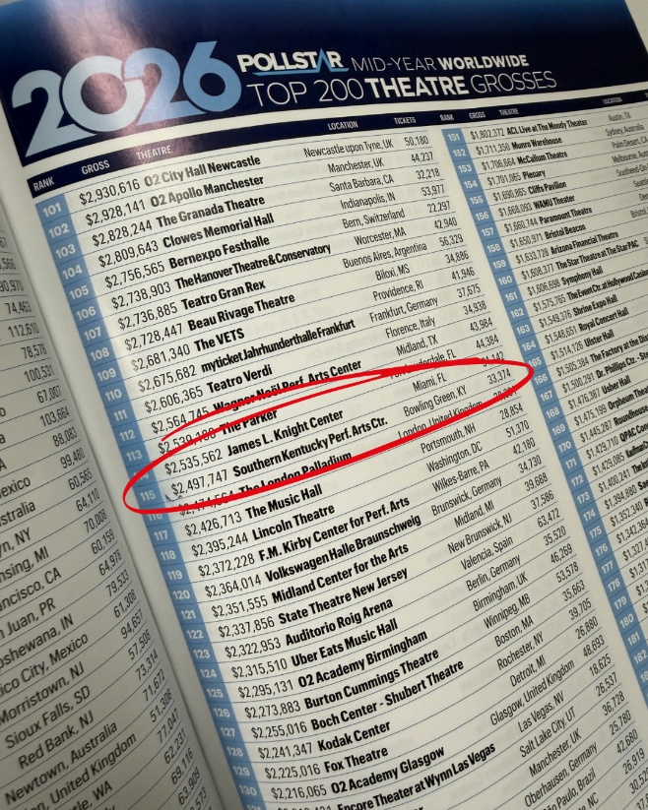

SKYPAC places No. 115 worldwide in Pollstar’s all-size mid-year theatre gross-sales rankings after earlier being named Pollstar’s No. 8 Venue of the Month in its capacity class.

BOWLING GREEN, KY – The Southern Kentucky Performing Arts Center has been named one of the top-grossing theatre venues in the world by Pollstar, the live entertainment industry’s leading trade publication, ranking No. 115 worldwide in Pollstar’s 2026 Mid-Year Top 200 Theatre Grosses report.
For the reporting period November 13, 2025, through May 13, 2026, SKYPAC generated $2,497,747 in gross ticket sales, making it the highest-ranked theatre in Kentucky and placing Bowling Green alongside many of the world’s leading live entertainment markets on Pollstar’s worldwide mid-year gross-sales chart.
The recognition continues a strong run of international industry attention for SKYPAC. Earlier this year, Pollstar named SKYPAC a Venue of the Month in the 1,501–2,500 capacity category for the period August 26 through September 22, 2025, ranking the venue No. 8 worldwide in that class. The new mid-year ranking is even more significant because it was not limited to similarly sized venues; it placed SKYPAC among theatres of all sizes worldwide.
“Pollstar’s rankings are one of the clearest benchmarks in the live entertainment business, so to see SKYPAC listed among the world’s top-grossing theatres is a major achievement for Bowling Green and all of South-Central Kentucky,” said Jeffrey Reed, President & CEO of SKYPAC. “What makes this especially meaningful is that we are competing from a market dramatically smaller than most of the cities represented on this list. This recognition reflects the quality of our programming, the loyalty of our audiences, and the growing reputation of SKYPAC as a venue that can perform on a global stage.”
A global ranking from a regional market
Pollstar’s mid-year Top 200 Theatre Grosses list is dominated by venues in major metropolitan areas, tourism centers, and international entertainment capitals. SKYPAC’s inclusion is notable not simply because it made the list, but because it did so from a comparatively small market while outperforming theatres in far larger cities and more established entertainment destinations.

In worldwide gross ticket sales, SKYPAC ranked ahead of venues such as:
- The London Palladium (#116) in London, England
- Lincoln Theatre (#118) in Washington, D.C.
- Uber Eats Music Hall (#124) in Berlin, Germany
- Boch Center – Shubert Theatre (#127) in Boston
- The Fox Theatre (#129) in Detroit
- Encore Theater at Wynn Las Vegas (#131) in Las Vegas
- Eccles Theater (#132) in Salt Lake City
- Peter Kiewit Concert Hall (#145) in Omaha
- Charleston Music Hall (#146) in Charleston
- ACL Live at the Moody Theater (#151) in Austin
- Lexington Opera House (#188) in Lexington

For a theatre in Bowling Green to rank ahead of venues in Washington, London, Las Vegas, Miami, Austin, Salt Lake City, Boston, and Lexington is a remarkable accomplishment — and a clear sign that SKYPAC is competing well beyond what would normally be expected of a venue in a city of its size.
Kentucky’s highest-ranked theatre on the list
SKYPAC’s placement at No. 115 worldwide made it the highest-ranked theatre in Kentucky on Pollstar’s mid-year gross-sales list, further solidifying its position as one of the Commonwealth’s leading performing arts institutions.
The ranking is especially meaningful because it reflects actual ticket revenue, one of the clearest measures of a venue’s market performance. In an industry where Pollstar rankings are closely watched by artists, agents, promoters, managers, and venue professionals, SKYPAC’s placement signals that Bowling Green is supporting a performing arts center capable of attracting major live entertainment and producing results comparable to theatres in far larger markets.
The ranking also underscores SKYPAC’s role as an economic and cultural driver for the region, drawing audiences to downtown Bowling Green and reinforcing South Central Kentucky’s growing reputation as a destination for first-class live entertainment.
“This kind of recognition does not happen by accident,” Reed said. “It reflects years of investment in the arts, strong support from our patrons, donors and sponsors, and a community that has embraced SKYPAC as a destination for world-class entertainment. We are proud of this ranking because it says something important about where SKYPAC stands today — not just locally or regionally, but in the broader live entertainment industry.”
Momentum on a world stage
Taken together, Pollstar’s recognition of SKYPAC as a Venue of the Month and its placement in the Top 200 worldwide theatre grosses points to sustained momentum for the Bowling Green venue.
Since opening in 2012, SKYPAC has grown into a regional destination for concerts, Broadway performances, family entertainment, educational programming, and community events. Pollstar’s recognition places that growth in a larger context: not simply as a local success story, but as a venue whose performance is now being measured against theatres around the world.
For Bowling Green and South-Central Kentucky, the ranking is more than a point of pride. It is evidence that the region has built and supported a performing arts center capable of delivering at a level recognized by the leading publication in the live entertainment business.

ABOUT SKYPAC
The Southern Kentucky Performing Arts Center is South Central Kentucky’s premier performing arts venue, presenting concerts, Broadway performances, family entertainment, educational programming, and community events. Located in downtown Bowling Green, SKYPAC is home to Orchestra Kentucky, Ramsey Theatre Company, and BG OnStage, and serves as a cultural hub for the region.

